Use Case Model Survey
FOR
Volunteer Management System
(VMS)

CLIENT
PROJECT | Volunteer Management System (VMS)
TITLE | Use Case Model Survey
VERSION | 0.1a
DATE | 28-Feb-2011
 | ORIGINATOR
 | Name / Signature | Team 8S
 | APPROVAL
 | Name / Signature | Phung Kim Cuong, Dio
Institute of Systems Science |  | Document Reference
25 Heng Mui Keng Terrence  Singapore 119615 |  | VMS/PM-1.3.1/1

 | Acceptance
 | Customer Signature |  | Customer Signature
 | Name & Designation |  | Name & Designation
 | Date & Company Stamp |  | Date & Company Stamp

Revision History

Date | Version | Description | Author
12-Jun-2011 | 0.1a | Creation | Team 8S
 |  | Refer to amendment history

Table of Contents

1. Introduction 3
2. Survey Description 3
3. Actors 3
3.1 Volunteer 3
3.2 Member 3
3.3 Leader 3
3.4 Staff 3
3.5 Application Administrator 3
3.6 System Administrator 3
3.7 Coordinator 4
3.8 Project Manager 4
3.9 Batch Scheduler 4
4. Use Case 4
4.1 Login / Logout 4
4.2 Change Password 4
4.3 Forget Password 4
4.4 Register User Account 4
4.5 Update Profile 4
4.6 Browse Project 4
4.7 Raise Interest 4
4.8 Propose Project 5
4.9 Post Experience 5
4.10 Post Feedback 5
4.11 Request for Certificate 5
4.12 Manage Project 5
4.13 Review Project 5
4.14 Assign Project Member 5
4.15 Manage Itinerary 5
4.16 Submit Itinerary Project 5
4.17 Review Itinerary 5
4.18 Manage Calendar 5
4.19 Review Feedback 6
4.20 Review Project Interest 6
4.21 Print Certificate 6
4.22 Generate Certificate By Batch 6
4.23 Manually Manage Certificate 6
4.24 Generate Report 6
5. Views 7
ANNEX D Amendment History 8

Introduction
The purpose this document is to provide a brief description of the project and to describe known actors and their interaction with the system. This document presents a high level view. The main requirements for the system are defined in “User Requirements Specification for Volunteer Management System”, reference VMS/T-1.2/1. The system is to be developed using object-oriented techniques and the Java programming language. For more detailed information, the reader will need to see the individual use case reports.

Survey Description
The scope of this document is to describe the functions that a volunteer or staff can perform in the volunteer management system.

Actors

Volunteer
This actor represents a person a volunteer who wishes to participate in doing volunteer work at project sites. He can be a project member or project leader for a project site. A volunteer can register himself as a volunteer in order to participate in the project site.

Member
This actor represents a person a volunteer whom is assigned as a project member for a project. He will be able to browse for projects and raise interest on projects that he is interested in. He will also be able to post personal experience and feedback regarding a project. Request for certification of volunteer work and manage it’s own user profile.

Leader
This actor represents a person a volunteer whom is assigned as a project leader for a project. He will be able to browse for projects and raise interest on projects that he is interested in. He will also be able to post personal experience and feedback regarding a project. Request for certification of volunteer work and manage it’s own user profile.

Staff
This actor represents a staff who works for the volunteer organisation. A staff will be able to update their user profile and change password.

Application Administrator
This actor represents an application administrator who performs configuration of the parameters that will be used by the system.

System Administrator
This actor represents a system administrator who manages the user accounts within the system, generate and print certificates.

Coordinator
This actor represents a coordinator that participates in reviewing of itinerary and project.

Project Manager
This actor represents a project manager that is in charge of managing the project sites that has been assigned. Managing of itinerary and calendar for each assigned project site. Reviewing of feedback and project interest that has been submitted by volunteers. Performing assignment of volunteers to appropriate projects and submit itinerary for reviews.

Batch Scheduler
This actor represents a batch scheduler program that triggers the batch jobs to be executed based on predefined scheduled.

Use Case

Login / Logout
This use case allows the user to login and logout of the system when he wishes to use the system or to exit from using the system.

Change Password
This use case allows all the users of the system to change their password.

Forget Password
This use case allows all the users of the system to submit for request to reset their password in the event that they have forgotten their password.

Register User Account
This use case allows a user who is interested to become a volunteer to register an account in the system.

Update Profile
This use case allows all the users who have a registered account in the system to update their user profile.

Browse Project
This use case allows a volunteer to browse for projects that are within the volunteer organisation.

Raise Interest
This use case allows a volunteer to raise interest for projects that he is interested in to participate in helping.

Propose Project
This use case allows a volunteer or staff to propose project site to the volunteer organisation.

Post Experience
This use case allows a volunteer to post personal, interesting experience to share with the public.

Post Feedback
This use case allows a volunteer to post feedback regarding a project.

Request for Certificate
This use case allows a volunteer to request for certificate on the project site that he has participated. It also allows a project manager to request for certificate on behave of his project team.

Manage Project
This use case allows a project manager to create, update and view a project details.

Review Project Proposal
This use case allows a project sponsor to review a project proposal and to decide whether to approve or reject a project proposal.

Assign Project Member
This use case allows a project manager to assign volunteers as project members or project leader to the various projects.

Manage Itinerary
This use case allows a project manager to create, update and view a project itinerary.

Submit Itinerary Project
This use case allows a project manager to submit the prepared itinerary for approval.

Review Itinerary
This use case allows a coordinator to review and to approve or reject a submitted itinerary.

Manage Calendar
This use case allows a project manager to setup a calendar by referencing the approved project itinerary.

Review Feedback
This use case allows a project manager to review and response to feedback that is posted by volunteers.

Review Project Interest
This use case allows a project manager to review a list of requested volunteers who wishes to join a specific project

Print Certificate
This use case allows the system administrator to print the certificates of a volunteer for the projects that he has previously participated in.

Generate Certificate By Batch
This use case allows the system administrator to generate certificates by batch for multiple volunteers when there is request of certification from project manager or volunteers.

Generate Certificate Manually
This use case allows the system administrator to manually generate certificates for individuals when there is request of certification from project manager or volunteers.

Generate Report
This use case allows the batch scheduler to generate reports based on predefined schedule.

Send Project Invitation
This use case allows project manager to compile an invitation, and then send it to all volunteers via email inviting them to join a certain project. The email will contain the link to the page where volunteer can response to the invitation and indicate their preferences.

Views
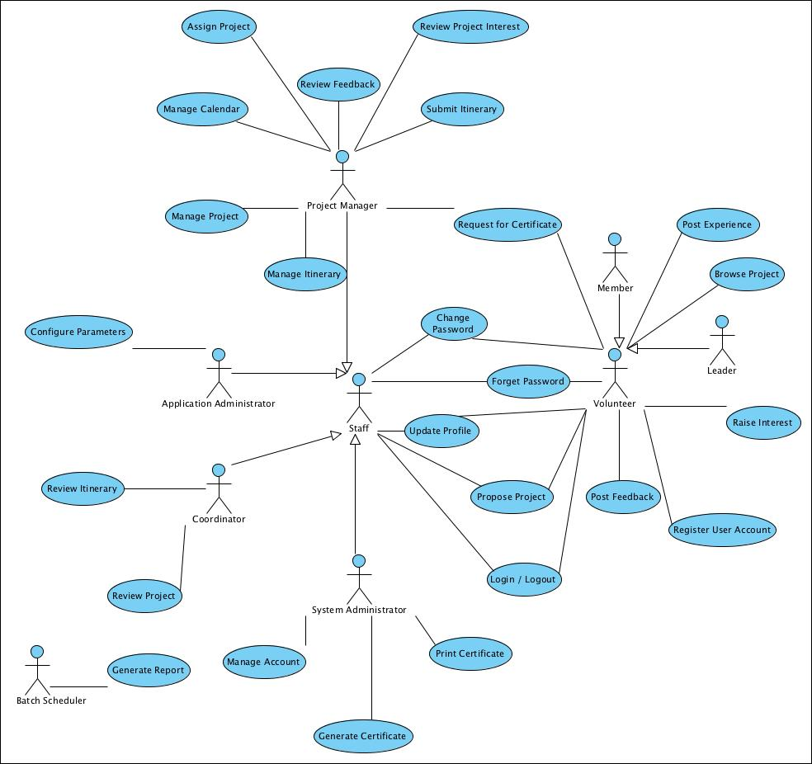

ANNEX D Amendment History

This is a record of all amendments made to the Document.
Version | Chapter / Section | Page No | Notes of Amendments or Changes

